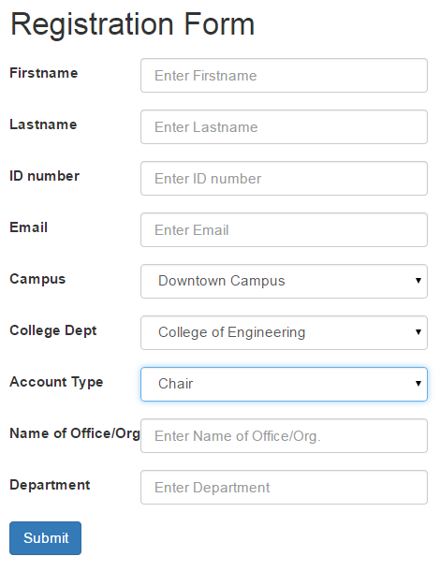

1. Firstname Text Field

* Description: This is where the Staff registers the user’s Firstname.
* Action: Staff inputs Firstname

1. Lastname Text Field

* Description: This is where the Staff registers user’s Lastname.
* Action: Staff inputs Lastname

1. ID number Text Field

* Description: This is where the Staff registers user’s ID number.
  + Action: Staff inputs ID number

1. E-mail Text Field
   * Description: This is where the staff inputs the user’s email address.
   * Action: Staff inputs email address.
2. Campus Dropdown Button
   * Description: This is where the staff selects the user’s campus.
   * Action: Staff selects the campus.
3. College Dropdown Button
   * Description: This is where the staff selects the user’s college.
   * Action: Staff selects the college.
4. User type Dropdown Field
   * Description: This is where the staff selects the user’s user type (faculty, dean, student organizations, Office, VP- Academics, VP-Admin)
   * Action: Staff inputs the Start time of the user’s duty.
5. Name of Office or Student organization text Field
   * Description: This is where the Staff inputs the name of Office or Student organization
   * Action: Staff inputs the name of the Office or Student Organization and it will only appear depending user’s type; either office or student organization.
6. Department Text Field
   * Description: This is where the Staff inputs department name
   * Action: Staff inputs the name of the department name and it will only appear if the user type is a student organization.
7. Submit Button
   * Description: This is where the Staff clicks when done registering the user.
   * Action: On click, the information will be saved in the database and will prompt that it is successfully registered.